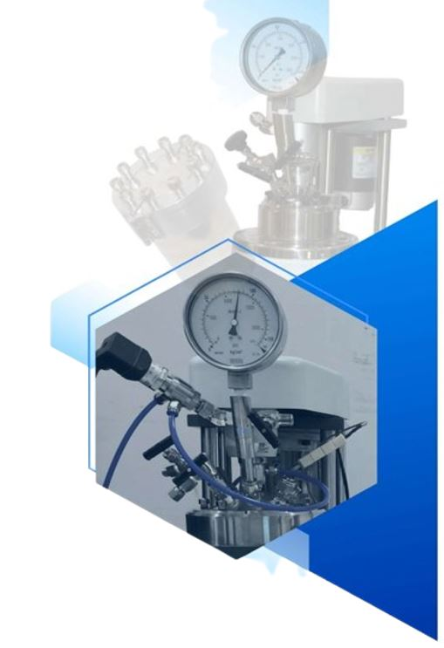
Designing and
Building
Quality Pressure
Apparatus
INDO AEROGELS AND MEMBRANES
Plot No. RMS-20, Rabale MIDC,
Navi Mumbai-400701
Email: indomembranes@gmail.com
Phone No. +91-9145125010
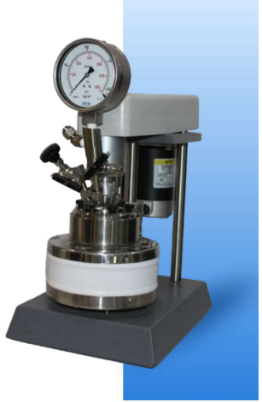
High Pressure Compact Laboratory Reactor

These are compact removable head reactor capacity 25 to 160 ml. these are for users who do not require wide variety of options or investigators with limited space or budgets, Investigators building multiple reactor installations for combinatorial chemistry or high throughput investigations can stack these reactors with common controller.

These vessels are rated for maximum working pressure of 200 bar.

The maximum operating temperature with PTFE gasket for up to 350°C

The 25, 50,100 and 160 ml reactors are equipped with gas inlet and outlet valves, a liquid sampling valve, pressure gage, safety rupture disc, internal thermocouple and external thermocouple in addition to the internal stirrer.
Due to limited space, internal cooling loop can not be provided. As option, cold finger can be used.

Model number | C-SR1020 | C-SR1323 | C-SR1346 |  | C-SR2020 |  | C-SR2520
Volume ml | 25 | 50 | 100 |  | 100 |  | 160
Maximum pressure | 3000 psig (200 bar)
Maximum Temperature | 350 Deg centigrade
Temperature Sensor | Type K Thermocouple
Vessel Internal Dia. mm | 25 | 34 | 34 |  | 50 |  | 64
Vessel Internal Depth mm | 50 | 58 | 115 |  | 50 |  | 50
Closure | Split ring with six compression bolts, PTFE gasket
Motor | Motor Variable speed DC motor 90 watt 0~1750 RPM
Drive | Zero leak magnetic drive 16 KgF-Cm torque
Impeller 4 blade Dia. mm | 25 | 50 | 100 |  | 100 |  | 160
Internal Cooling option | N.A | Cold finger |  | Cold finger |  | Cold finger
Valve | Swagelok 1/8” NPT, outlet 0.25 inch tube adaptor gas inlet, liquid sampling, gas vent
Pressure Gauge | 0~3000 psig/200 bar,100 mm dia
Heater mounted on stand | 400W | 400W | 600W |  | 400W |  | 400W
Controller | Programmable temperature control with DC-SSR, RPM control with DC regulated power supply, over temperature safety cut-off. Display of reactor temperature, RPM heater temperature, option for pressure display
Power | Power 230 V 50 Hz.1 phase
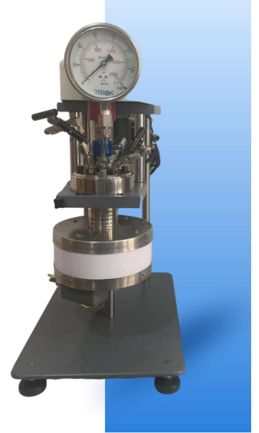
High Pressure Bench Top Laboratory Reactors Series 13X
These are standard removable head or fixed head reactors capacity 25 to 100 ml.
These vessels are rated for maximum working pressure of 200 bar.
The maximum operating temperature with PTFE gasket for up to 350 °C
The reactor are equipped with gas inlet and outlet valves, a liquid sampling valve, pressure gage, safety rupture disc, internal thermocouple and external thermocouple in addition to the internal stirrer.
The mounting is on base plate with four buffers to take vibrations at high RPM
The heavy-duty base allows to use various options like BPR, condenser, cooling coil etc.

Model number | BT-SR1020 | BT-SR1323 | BT-SR1346
Volume ml | 25 | 50 | 100
Maximum pressure | 3000 psig (200 bar)
Maximum Temperature | 350 Deg Centigrade
Temperature Sensor | Type K Thermocouple
Vessel Internal Dia. mm | 25 | 34 | 34
Vessel Internal Depth mm | 50 | 58 | 115
Closure | Split ring with PTFE gasket (Six 3/8” UNF compression bolts)
Motor | Variable speed DC motor 90 watt 0~3000 RPM
Drive | 16 kgF-Cm torque with belt drive for 0-2000 RPM
Impeller 4 blade Dia. mm | 21 | 21 | 21
Internal Cooling option | Cold finger
Valve | Swagelok 1/8” NPT, outlet 0.25 inch tube adaptor gas inlet, liquid sampling, gas vent
Pressure Gauge | 0~3000 psig/200 bar, 100 mm Dia.450W
Heater mounted on stand | 450W | 450W | 450W
Controller | Programmable temperature control with DC-SSR, RPM control with DC regulated power supply, over temperature safety cut-off. Display of reactor temperature, RPM heater temperature, option for pressure display
Power | Power 230 V 50 Hz.1 Phase

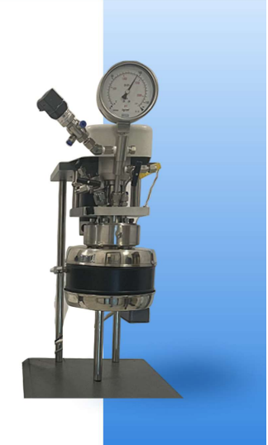
High Pressure Beach Top Laboratory Reactor Series 25X
These are standard removable head or fixed head reactors capacity 100 to 600 ml.
These vessels are rated for maximum working pressure of 200 bar.
The maximum operating temperature with PTFE gasket for up to 350 °C
The reactors are equipped with gas inlet and outlet valves, a liquid sampling valve, pressure gage, safety rupture disc, internal thermocouple and external thermocouple in addition to the internal stirrer.
The mounting is on base plate with four buffers to take vibrations at high RPM
The heavy duty base allows to use various options like BPR, condenser, cooling coil etc.

Model number | BT-SR2020 | BT-SR2520 | BT-SR2540 | BT-SR2565 | BT-SR2580
Volume ml | 100 | 160 | 300 | 500 | 600
Maximum pressure | 3000 psig (200 bar)
Maximum Temperature | 350 Deg centigrade
Temperature Sensor | Type K Thermocouple
Vessel Internal Dia. mm | 50 | 64 | 64 | 64 | 64
Vessel Internal Depth mm | 50 | 50 | 100 | 160 | 190
Closure | Split ring with PTFE gasket (Six 3/8” UNF compression bolts)
Motor | Motor Variable speed DC motor 90 watt 0~3000 RPM
Drive | 16 KgF-Cm torque with belt drive for 0~2000 RPM
Impeller 4 blade Dia. mm | 31 | 39 | 39 | 39 | 39
Internal Cooling option | N.A | Cooling Loop Option
Valve | Swagelok 1/8” NPT, outlet 0.25 inch tube adaptor gas inlet, liquid sampling, gas vent
Pressure Gauge | 0~3000 psig/200 bar,100 mm dia
Heater | 450W | 450W | 600W | 850W | 850W
Controller | Programmable temperature control with DC-SSR, RPM control with DC regulated power supply, over temperature safety cut-off. Display of reactor temperature, RPM heater temperature, option for pressure display
Power | Power 230 V 50 Hz.1 phase
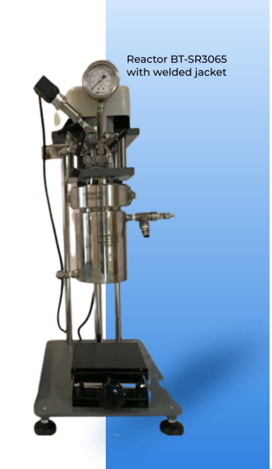
High Pressure Beach Top
Laboratory Reactor Series 30X

These are standard removable head or fixed head reactors capacity 500 ml to 750 ml.

These vessels are rated for maximum working pressure of 140 bar.

The maximum operating temperature with PTFE gasket for up to 350 °C

The reactors are equipped with gas inlet and outlet valves, a liquid sampling valve, pressure gage, safety rupture disc, internal thermocouple and external thermocouple in addition to the internal stirrer.

The mounting is on base plate with four buffers to take vibrations at high RPM

The heavy-duty base allows to use various options like BPR, condenser, cooling coil etc.

Model number | BT-SR3045 | BT-SR3065
Volume ml | 500 | 750
Maximum pressure | 2000 psig (140 bar)
Maximum Temperature | 350 Deg centigrade
Temperature Sensor | Type K Thermocouple
Vessel Internal Dia. mm | 76 | 76
Vessel Internal Depth mm | 115 | 165
Closure | Split ring with PTFE gasket (Six 3/8” UNF compression bolts)
Motor | Variable speed DC motor 90 watt 0~3000 RPM
Drive | 16 KgF-Cm torque with belt drive for 0~2000 RPM
Impeller 4 blade Dia. mm | 39 | 39
Internal Cooling option | Cooling Loop option
Valve | Swagelok 1/8” NPT, outlet 0.25 inch tube adaptor gas inlet, liquid sampling, gas vent
Pressure Gauge | 0~3000 psig/200 bar,100 mm dia
Heater | 850W | 1000W
Controller | Programmable temperature control with DC-SSR, RPM control with DC regulated power supply, over temperature safety cut-off. Display of reactor temperature, RPM heater temperature, option for pressure display
Power | Power 230 V 50 Hz.1 Phase
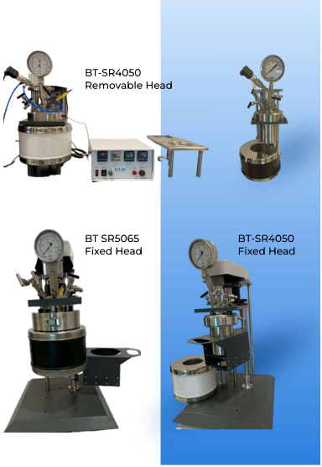
High Pressure Beach Top Laboratory Reactor Series 40X

These are standard removable head or fixed head reactors capacity 1000 ml to 2000 ml.

These vessels are rated for maximum working pressure of 140 bar. The maximum operating temperature with PTFE gasket for up to 350 °C

The reactors are equipped with gas inlet and outlet valves, a liquid sampling valve, pressure gage, safety rupture disc, internal thermocouple and external thermocouple in addition to the internal stirrer.

The mounting is on base plate with four buffers to take vibrations at high RPM

The heavy-duty base allows to use various options like BPR, condenser, cooling coil etc.

Model number | BT-SR4050 | BT-SR40100 | BT-SR5065
Volume ml | 1000 | 2000 | 2000
Maximum pressure | 2000 psi (140 bar)
Maximum Temperature | 350 Deg Centigrade
Temperature Sensor | Type K Thermocouple
Vessel Internal Dia. mm | 100 | 100 | 125
Vessel Internal Depth mm | 130 | 260 | 165
Closure | Split ring with PTFE gasket (Six 3/8” UNF compression bolts)
Motor | Variable speed DC motor 90 watt 0~3000 RPM
Drive | 16 KgF-Cm torque with belt drive for 0-1500 RPM
Impeller 4 blade Dia. mm | 65 | 65 | 80
Internal Cooling option | Serpentine cooling coil
Valve | Swagelok 1/4” NPT, outlet 0.25 inch tube adaptor gas inlet, liquid sampling, gas vent
Pressure Gauge | 0~2000 psig/140 bar,100 mm dia
Heater | 1000W | 1500W | 1500W
Controller | Programmable temperature control with DC-SSR, RPM control with DC regulated power supply, over temperature safety cut-off. Display of reactor temperature, RPM heater temperature, option for pressure display
Power | Power 230 V 50 Hz.1 phase
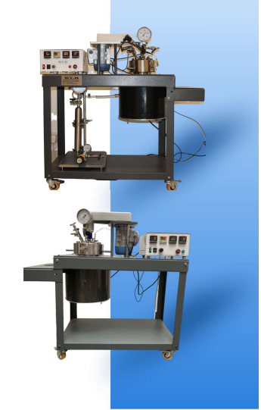
High Pressure Cart Mount Reactors Series

These are standard removable head reactor mounted on cart with heavy duty casters; capacity 1000 ml to 2000 ml.

The cart design allows reactor to be placed on either side. These vessels are rated MWAP 140 bar. The maximum operating temperature with PTFE gasket for up to 350 °C

The reactors are equipped with gas inlet and outlet valves, a liquid sampling valve, pressure gage, safety rupture disc, internal thermocouple and external thermocouple in addition to the internal stirrer.
Can be provided with 375 watt motor with pulley and belt
Model number | CT-SR-40.50 | CT-SR-40.100 | CT-SR-60.110
Volume ml | 1000 | 2000 | 5000
Maximum pressure | 5000 psi (345 bar)
Working pressure | 4351 psi (300 bar)
Maximum Temperature | 350 Deg centigrade
Temperature Sensor | Type K thermocouple
Vessel Internal Dia. mm | 100 | 100 | 152
Vessel Internal Depth mm | 130 | 260 | 280
Closure | Split ring, 3/8” UNF compression bolt |  | 5/8” UNF bolt
Gasket | PTFE or flexible graphite
Motor | Variable speed DC motor 375-watt 0~2800 RPM
Magnetic drive | 60 KgF-Cm torque with belt drive for 0-1750 RPM
Impeller 4 blade Dia. mm | 65 | 65 | 80
Internal cooling option | Serpentine cooling coil
Valve | Swagelok 1/4” NPT, outlet 0.25 inch tube adaptor gas inlet, liquid sampling, gas vent
Pressure Gauge | 0~2000 psig /140 bar,100 mm dia
Heater | 1000W | 2500W | 3000W
Mounting | Trolley (SS/powder coated MS)
Cooling system | Auto cooling with motor mounted on SS tank of water with solenoid valve for cooling of magnetic drive
Controller | Programmable temperature control with DC-SSR, RPM control with DC regulated power supply, over temperature safety cut-off. Display of reactor temperature, RPM heater temperature, option for pressure display
Power | Power 230 V 50 Hz.1 Phase

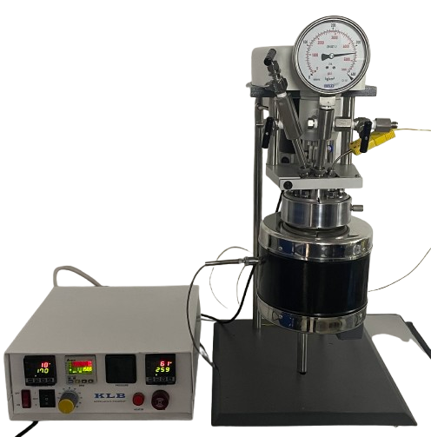
High Pressure Bench Top Laboratory
HPHT Reactors Series 13 X 25 X

13 x 25 x fixed head reactors capacity 100 ml to
500 ml can be modified to high pressure & High
Temperature (HPHT) application.

These vessels are rated for maximum operating
temperature to 500 Deg C with flexible graphite gasket

The head fittings are high pressure cone fittings with
Gland and compression nut to withstand high temperature.

The reactors are equipped with gas inlet and outlet valves,
a liquid sampling valve, pressure gage, safety rupture disc,
internal thermocouple, and external thermocouple in
addition to the internal stirrer.

Model number | BT-SR1346HPHT | BT-SR2540HPHT | BT-SR2565HPHT
Volume ml | 100 ml | 300 ml | 500 ml
Maximum pressure | 5000 psig | 2000 psig 2000 psig
Maximum Temperature | 500 Deg centigrade
Temperature Sensor | Type K thermocouple
Vessel Internal Dia. mm | 34 | 64 | 64
Vessel Internal Depth mm | 115 | 100 | 160
Closure | Split ring with graphite gasket (six 3/8” UNF bolts)
Motor | Variable speed DC motor 90 watt 0~3000 RPM
Magnetic Drive | 16 kgf-cm torque with belt drive for 0~1800 RPM
Impeller 4 blade Dia. mm | 21 mm | 39 mm | 39 mm
Internal Cooling option | Not available | Cooling loop
Valve | Swagelok 1/8” NPT, outlet 0.25 inch tube adaptor gas inlet, liquid sampling, gas vent
Pressure Gauge | 0~5000 psig | 0~2000 psi (140 bar) 100 mm dia.
Heater | 1000W | 1000W | 1200W
Controller | Programmable temperature control with DC- SSR, RPM control with DC regulated power supply, over temperature safety cut-off. Display of reactor temperature, RPM, heater temperature, option for pressure display
Power | Power 230 V 50 Hz. l phase

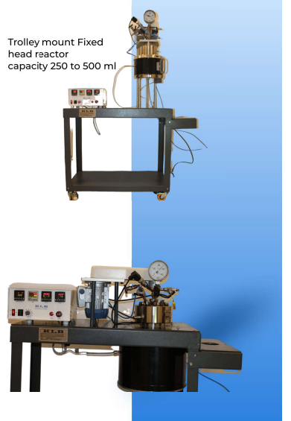
High Pressure Trolley Mount
Reactor Series CT-SR-HPHT
These Vessels are rated for maximum working pressure of 5000 PSI.
The maximum operation temperature with PTFE gasket for up to 300 °C with flexible graphite gasket up-to 500 Deg C
The reactors are equipped with gas inlet and outlet valves, a liquid sampling valve, pressure gage, safety rupture disc, internal thermocouple and external thermocouple in addition to the internal stirrer.
Trolley mount
Removable head reactor
Capacity 1000 ml to 2000 ml

Model number | CT-SR-2530 FH | CT-SR-2565 FH | CT-SR-4050 RH | CT-SR-40.100 RH
Volume ml | 250 | 500 | 1000 | 2000
Maximum pressure | 5000 psig
Maximum Temperature | 500 Deg centigrade
Temperature Sensor | Type K Thermocouple or RTD sensor
Vessel Internal Dia. Mm | 64 | 64 | 95 | 95
Vessel Internal Depth mm | 85 | 160 | 135 | 270
Closure | Split ring with gasket (ten 5/8” UNF compression bolts) |  | Split ring with gasket (twelve 5/8” UNF compression bolts)
Motor | Variable speed Ac motor 180 watt 0~1400 RPM with VFD drive
Magnetic drive | 16 kgF-cm torque with belt drive for 0-1400 RPM |  | 20 kgF-cm torque with belt drive for 0-1400 RPM
M.D. Mounting | Nickel compression gasket
Impeller Dia. mm | 39 mm |  | 56 mm
Valve | Swagelok needle valve with grafoil seat, outlet 0.25 inch tube adaptor gas inlet ,liquid sampling, gas vent
Pressure gauge | 0~5000 psig/350 bar, 100 mm dia
Heater | 800W | 1000W | 1500W | 2500W
Controller | Programmable temperature control with DC-SSR, VFD drive for control, position sensor for RPM measurement, over temperature safety cut-off, display of reactor temperature, RPM heater temperature, option for pressure display
Power | Power 230 V 50 Hz.1 Phase
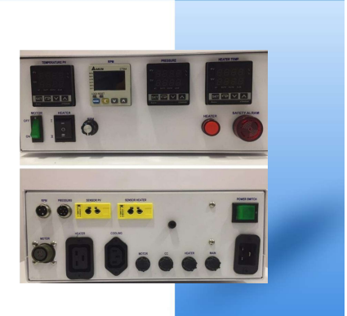
Controllers 4X48

The controller can be provided with
Four slots (48x48)
or
Five slots (Three 48x48, two 48x24)

PID (Proportional – Integral – Derivative) with Ramp & Soak
RPM Display
Pressure Display
Vessel surface temperature display
Motor current display
RS 485 interface

Microprocessor controllers operate with three different mode.

PID (Proportional – Integral – Derivative)
Proportional-Integral-Derivative systems have three control functions. Proportional control adjusts the heating in proportion to the temperature difference from the set point. Integral function compensates for any temperature control offset from the set point. The derivative function deals with the rate of change of the temperature.

This control can rapidly bring a system to a desired temperature with little or no overshoot and smooth, continuous regulation. These controllers are now self-tuning so that they can set the proportional band, compensate for any offset and adjust the proportional action to ensure that the temperature in the controlled system will be held at the set point with minimal deviation.

Ramp and Soak Programming
This control option allows the operator to program a time and temperature profile into the controller for automatic execution. This can consist of a series of different temperature settings and the length of time length of time each is to be held. The rate of change from one setting to another can also be controlled if the changes are within the capability of the heating and /or cooling system. An additional feature provides for control of the approach to a critical temperature when over-shoots cannot be tolerated. A visual display prompts for all programming and timing functions.

Cascade control
This control option utilizes two temperature sensors: One internal and one external to provide superior performance in difficult control systems.
Additional external temperature module is added to control unit to read control heater temperature.

This is particularly effective for heating system with large thermal lags, such as thick – walled vessels or vessels with glass or PTFE liners, with low operating temperature; where temperature overshoot has to be avoided.

Separate Heating and Cooling Control Loops
The controllers actually have two separate PID control loops; one for heating and a second one for cooling. The second loop with its own self-tuning parameters can be used to activate a solenoid valve to control the flow of coolant through an installed cooling coil.
Control module specifications
Operating range | 0-600 °C
Digital readout resolution | 1°C
Digital set point resolution | 1°C
System accuracy | +/-2 °C
High limit alarm | Red Led and audio
Thermocouple burnout prot. | Yes
Thermocouple | Type K
Communications module | Serial port RS485

Option 1 RPM Display Module
This module provides a means for continuously monitoring the stirring speed in reactor, offering a particularly valuable feature since all reactors are normally equipped with variable speed motors with real time position sensor. The digital display will show the stirring speed with 1 rpm resolution and +/- 5 rpm accuracy.

Option 2 Pressure Display Module
This module provides a digital readout for continuously monitoring the pressure within the reactor, plus a back-up safety feature which will shut down the heater if a pre-set maximum pressure is reached. Pressure is displayed with 1 psi resolution and 10 psi accuracy normally calibrated from 0 to 250 bar. Higher or lower ranges are available by special order. The safety cut-off feature offers excellent protection against accidental over-pressurization by allowing the user to set a maximum pressure which, if reached, will activate a lock out relay and shut down the system heater immediately. The signal for the pressure display is generated by a transducer in a stainless steel housing mounted on the reactor near the pressure gage.

Option 3 Heater Temperature Cut-off Module
This module provides a completely redundant high temperature safety cut-off which will shut down the heater in case of an unusual malfunction in the primary control system.
The option also provides a means for measuring vessel wall temperatures to avoid temperature overshoot and /or to protect PTFE liner.

Option 4 Current Display Module
This module provides a means for continuously monitoring the current being drawn by the stirrer motor. Since the motor speed control will provide a constant stirring speed at any given setting, changes in the current drawn by the motor will correspond to changes in the viscosity of the reactants in the vessel. This will be a useful option for users who want to monitor the progress of a polymerization reaction in which there is a viscosity change as the reaction proceeds.
Option 5 Solenoid Valve Module
This module provides a solenoid valve and all parts needed to assemble an automatic flow control system for controlling the flow of coolant through a cooling coil in any reactor. It usually is installed in a cold-water line with a flow connection to the cooling coil and an electrical connection to an output socket provided at rear side of controller.

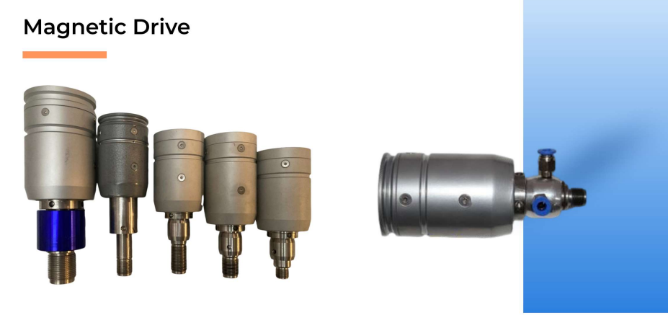

The stirred reactor are equipped with magnetic drive, to provide service free drive shaft to internal impeller.

These are high torque magnetic drive available as 16 KgF-Cm, 20 KgF-Cm, 50 KgF-Cm or 80 KgF-Cm torque.

The magnetic drives are assemble with specially designed Nd. Fe. B permanent magnets which have excellent temperature stability and can be depended upon to operate for long periods with little or no flux degradation.

Magnets for the inner rotor to which the stirrer shaft is attached are enclosed in a stainless steel (or other alloy) housing and supported by carbon-filled, PTFE bushings to provide a long life, chemically inert stirring system.

Magnets for the outer drive are also fully enclosed and supported by twin, high quality sealed ball bearings for smooth operation and long life.

These drives are provided with housing which is tested to 350 bar pressure. The mounting is 9/16-18 UNF or M16 for 16KgF Cm torque magnetic derive. The mounting port for 50 KgF-Cm can be M24 or 1” UNF and 80 KgF M28 or 1.25”UNF.

The magnetic drive is mounted on pressure vessel with compression gasket, MOC nickel or PTFE

A water-cooling sleeve attached to each drive protects the components from excessive heart arising from the reactor.

We can provide magnetic drive with 60-watt motor and RPM sensor. Complete unit can be mounted on M16 or 9/16 UNF port.

Warranty Terms

Indo Aerogels & Membranes reactors, pressure vessels and associated products are designed and manufactured only for use by or under the direct supervision of trained professionals in accordance with specifications and instructions for use supplied

For that reason, Indo aerogels and membranes sells only to professional end users.

Indo aerogels and membranes produces pressure reactors and associated products which are not intended for general commercial use.

Exclusive Warranty: To the extent allowed by law, the express and limited warranties herein are the sole warranties, any implied warranties are expressly excluded, including but not limited to implied warranties of merchantability or fitness for a particular purpose.

Warranty conditions:

- Non-assignable: The warranties herein extend only to the original purchaser-user. These warranties or any claims based there –on are not assignable or transferable.
- Use of product: The warranties herein are applicable and enforceable only when the product.

- Is installed and operated in strict accordance with the written instructions for its use.
- Is being used in a lawful manner, and
- Has been stored or maintained in accordance to instructions provided by Indo aerogels and membranes.
- The user’s responsibility: Indo aerogels and membranes engineers and sales personnel will gladly discuss available equipment and material option with prospective users, but the final responsibility for selecting a reactor or pressure vessel which has the capacity, pressure rating, chemical compatibility, corrosion resistance and design feature required to perform safely and to the user’s satisfaction in any application or test must rest entirely with the user; not with Indo aerogels and membranes.

It is also the user’s responsibility to install the equipment in a safe operating environment and to train all operating personnel in appropriate safety, operational and maintenance procedures.

- Warranty period: Unless otherwise provided in writing by Indo aerogels and membranes, the warranties herein are applicable for a period of one year from date of delivery of the product to the original purchaser/user. Note, however, that there is no guarantee of a service life of one year after delivery.

- Notification: To enforce any warranty created herein, the purchaser/user must notify Indo aerogels and membranes in writing within thirty (30 days) of the date any defect is detected.

Upon request of Indo aerogels and membranes, the part or product involved must be returned to Indo aerogels and membranes in the manner specified by Indo aerogels and membranes for analysis and non-destructive testing.

Subject to the above conditions, Indo aerogels and membranes expressly warrants that its products:

1. Are as described in the applicable sales literature, or as specified in shipping documents.

2. Will function as described in corresponding Indo aerogels and membranes sales bulletins or, for
Specially engineered assemblies, as stated in the sales proposal and purchase agreement.

3. Will remain free from defects in materials and workmanship for the warranty period.

Limitations on the warranty:
As to the original purchase/ user Indo aerogels and membranes its liability for claims other than personal injury as follows:

1. Replacement or repair with respect to express warranties herein, Indo aerogels and membranes only obligation is to replace or repair any parts, assemblies or products not conforming to the warranties provided herein.

2. Disclaimer of consequential damages. In no event shall Indo aerogels and membranes be liable for consequential commercial damages, including but not limited to: damages for loss of use, damages for lost profits, and damages for resulting harm to property other than the Indo aerogels and membranes.

Indemnity and hold harmless.
Original purchase-user-agrees to indemnify and hold Indo aerogels and membranes harmless for any personal injuries to original purchase-user, its employees and all third parties where said injuries arise from misuse of Indo aerogels and membranes products or use not in accordance with specification and instructions for use supplied with the Indo aerogels and membranes products.

User Responsibility

All reactor and pressure vessels are designed and manufactured with great care to ensure safe operation when used within their pre-scribed temperature and pressure limits. However the basic responsibility for safety when using this equipment rests entirety with the user; who must:

1. Reactor selection
Select a reactor or pressure vessel which has the capability, pressure rating. Corrosion resistance and design features that are suitable for its intended use.

Indo engineers will be glad to discuss available equipment and material options with prospective users, but the final responsibility for selecting a reactor or pressure vessel that will perform to the user’s satisfaction in any reaction or test must rest with the user, not with Indo. In exercising the responsibility for the selection of pressure equipment, the prospective user is often faced with a choice between over or under-designed pressure vessels are readily apparent, but the penalties that must be paid for over-designed apparatus are often overlooked.

Recognizing these criteria, Indo reactors and pressure vessels are offered in several different styles, each designed for convenient use in daily operation within certain temperature and pressure limits, using gaskets, closures and other elements carefully selected for safe operation within the limits specified for that design. But in order to preserve the validity of these designs, all temperature and pressure limit must be observed, and no attempt should be made to increase these limit by making alterations or by substituting components which are not recommended by Indo.

2. Installation site
Install and operate the equipment within a suitable barricade, if required, with appropriate safety accessories and in full compliance with local safety codes and rules.

3. Operator Training
Establish training procedures to ensure that any person handling the equipment knows how to use it
properly.

4. Preventive Maintenance
Maintain the equipment in good condition and establish procedures for periodic testing to be sure the vessel remains structurally.

